SSN College of Engineering, Kalavakkam
Department of Computer Science and Engineering
III Semester - CSE 'A ',’B’ & ‘C’
UCS 1312 Data Structures Lab Laboratory

Academic Year: 2019-2020
Batch: 2018-2022

Register Number: 185001104
Name: Nivedhitha D
Class: CSE B

Exercise 12: Implementation of Dijkstra algorithm to find shortest Path from the given source vertex to all the other vertices of the graph

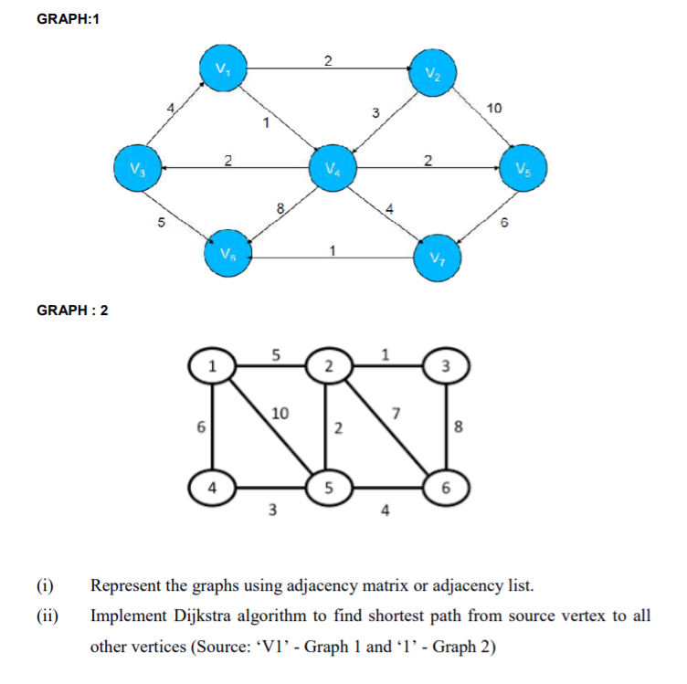

Program Name: Dijkstra

Source Code:

#include <stdio.h>
#include <stdlib.h>
#include <limits.h>

typedef int bool;
#define true 1
#define false 0

struct AdjListNode
{
int dest;
int weight;
struct AdjListNode* next;
};

struct AdjList
{
struct AdjListNode *head;
};

struct Graph
{
int V;
struct AdjList* array;
};

struct AdjListNode* newAdjListNode(int dest, int weight)
{
struct AdjListNode* newNode = (struct AdjListNode*) malloc(sizeof(struct AdjListNode));
newNode->dest = dest;
newNode->weight = weight;
newNode->next = NULL;
return newNode;
}

struct Graph* createGraph(int V)
{
struct Graph* graph = (struct Graph*) malloc(sizeof(struct Graph));
graph->V = V;

graph->array = (struct AdjList*) malloc(V * sizeof(struct AdjList));

for (int i = 0; i < V; ++i)
graph->array[i].head = NULL;

return graph;
}

void addEdge(struct Graph* graph, int src, int dest, int weight)
{
// Add an edge from src to dest. The node is added at the beginning
struct AdjListNode* newNode = newAdjListNode(dest, weight);
newNode->next = graph->array[src].head;
graph->array[src].head = newNode;

/* Since graph is undirected, add an edge from dest to src also
newNode = newAdjListNode(src, weight);
newNode->next = graph->array[dest].head;
graph->array[dest].head = newNode;*/
}

struct MinHeapNode
{
int v;
int dist;
};

typedef struct MinHeapNode MinHeapNode;

struct MinHeap
{
int size;
int capacity;
int *pos;
struct MinHeapNode **array;
};

struct MinHeapNode* newMinHeapNode(int v, int dist)
{
struct MinHeapNode* minHeapNode =
(struct MinHeapNode*) malloc(sizeof(struct MinHeapNode));
minHeapNode->v = v;
minHeapNode->dist = dist;
return minHeapNode;
}

typedef struct MinHeap MinHeap;

struct MinHeap* createMinHeap(int capacity)
{
struct MinHeap* minHeap =
(struct MinHeap*) malloc(sizeof(struct MinHeap));
minHeap->pos = (int *)malloc(capacity * sizeof(int));
minHeap->size = 0;
minHeap->capacity = capacity;
minHeap->array =
(struct MinHeapNode**) malloc(capacity * sizeof(struct MinHeapNode*));
return minHeap;
}

void swapMinHeapNode(struct MinHeapNode** a, struct MinHeapNode** b)
{
struct MinHeapNode* t = *a;
*a = *b;
*b = t;
}

//Insert into minHeap
void minHeapify(struct MinHeap* minHeap, int idx)
{
int smallest, left, right;
smallest = idx;
left = 2 * idx + 1;
right = 2 * idx + 2;

if (left < minHeap->size &&
minHeap->array[left]->dist < minHeap->array[smallest]->dist )
smallest = left;

if (right < minHeap->size &&
minHeap->array[right]->dist < minHeap->array[smallest]->dist )
smallest = right;

if (smallest != idx)
{
MinHeapNode *smallestNode = minHeap->array[smallest];
MinHeapNode *idxNode = minHeap->array[idx];

minHeap->pos[smallestNode->v] = idx;
minHeap->pos[idxNode->v] = smallest;

swapMinHeapNode(&minHeap->array[smallest], &minHeap->array[idx]);

minHeapify(minHeap, smallest);
}
}

int isEmpty(struct MinHeap* minHeap)
{
return minHeap->size == 0;
}

struct MinHeapNode* extractMin(struct MinHeap* minHeap)
{
if (isEmpty(minHeap))
return NULL;

struct MinHeapNode* root = minHeap->array[0];

struct MinHeapNode* lastNode = minHeap->array[minHeap->size - 1];
minHeap->array[0] = lastNode;

minHeap->pos[root->v] = minHeap->size-1;
minHeap->pos[lastNode->v] = 0;

--minHeap->size;
minHeapify(minHeap, 0);

return root;
}

// Function to decreasy dist value of a given vertex v.
void decreaseKey(struct MinHeap* minHeap, int v, int dist)
{
// Get the index of v in heap array
int i = minHeap->pos[v];

// Get the node and update its dist value
minHeap->array[i]->dist = dist;

// Travel up while the complete tree is not hepified.
// This is a O(Logn) loop
while (i && minHeap->array[i]->dist < minHeap->array[(i - 1) / 2]->dist)
{
// Swap this node with its parent
minHeap->pos[minHeap->array[i]->v] = (i-1)/2;
minHeap->pos[minHeap->array[(i-1)/2]->v] = i;
swapMinHeapNode(&minHeap->array[i], &minHeap->array[(i - 1) / 2]);

// move to parent index
i = (i - 1) / 2;
}
}

bool isInMinHeap(struct MinHeap *minHeap, int v)
{
if (minHeap->pos[v] < minHeap->size)
return true;
return false;
}

void printArr(int dist[], int n)
{
printf("\nVERTEX\t\tDISTANCE\n");
for (int i = 0; i < n; ++i)
printf("%d \t\t %d\n", i+1, dist[i]);
}

void dijkstra(struct Graph* graph, int src)
{
int V = graph->V;
int dist[V];

struct MinHeap* minHeap = createMinHeap(V);

for (int v = 0; v < V; ++v)
{
dist[v] = INT_MAX;
minHeap->array[v] = newMinHeapNode(v, dist[v]);
minHeap->pos[v] = v;
}

minHeap->array[src] = newMinHeapNode(src, dist[src]);
minHeap->pos[src] = src;
dist[src] = 0;
decreaseKey(minHeap, src, dist[src]);

minHeap->size = V;

while (!isEmpty(minHeap))
{
// Extract the vertex with minimum distance value
struct MinHeapNode* minHeapNode = extractMin(minHeap);
int u = minHeapNode->v; // Store the extracted vertex number

// Traverse through all adjacent vertices of u (the extracted
// vertex) and update their distance values
struct AdjListNode* pCrawl = graph->array[u].head;
while (pCrawl != NULL)
{
int v = pCrawl->dest;

// If shortest distance to v is not finalized yet, and distance to v
// through u is less than its previously calculated distance
if (isInMinHeap(minHeap, v) && dist[u] != INT_MAX &&
pCrawl->weight + dist[u] < dist[v])
{
dist[v] = dist[u] + pCrawl->weight;

// update distance value in min heap also
decreaseKey(minHeap, v, dist[v]);
}
pCrawl = pCrawl->next;
}
}

// print the calculated shortest distances
printArr(dist, V);
}

int main()
{
// creating the graphs
int V = 7;
struct Graph* graph1 = createGraph(V);

printf("SHORTEST DISTANCE FROM SOURCE BY DIJKSTRA'S ALGRITHM\n");

printf("\nGRAPH 1\n");

addEdge(graph1, 0, 1, 2);
addEdge(graph1, 0, 3, 1);
addEdge(graph1, 1, 3, 3);
addEdge(graph1, 1, 4, 10);
addEdge(graph1, 2, 0, 4);
addEdge(graph1, 3, 2, 2);
addEdge(graph1, 3, 4, 2);
addEdge(graph1, 3, 5, 8);
addEdge(graph1, 3, 6, 4);
addEdge(graph1, 4, 6, 6);
addEdge(graph1, 6, 5, 1);

dijkstra(graph1, 0);

V = 6;

struct Graph* graph2 = createGraph(V);

printf("\nGRAPH 2\n");

addEdge(graph2, 0, 1, 5);
addEdge(graph2, 0, 3, 6);
addEdge(graph2, 0, 4, 10);
addEdge(graph2, 1, 2, 1);
addEdge(graph2, 1, 4, 2);
addEdge(graph2, 1, 5, 7);
addEdge(graph2, 2, 1, 1);
addEdge(graph2, 2, 5, 8);
addEdge(graph2, 3, 0, 6);
addEdge(graph2, 3, 4, 3);
addEdge(graph2, 4, 0, 10);
addEdge(graph2, 4, 1, 2);
addEdge(graph2, 4, 5, 4);
addEdge(graph2, 5, 1, 7);
addEdge(graph2, 5, 2, 8);
addEdge(graph2, 5, 4, 4);

dijkstra(graph2, 0);

return 0;
}

Output:

SHORTEST DISTANCE FROM SOURCE BY DIJKSTRA'S ALGORITHM

GRAPH 1
VERTEX DISTANCE
1 0
2 2
3 3
4 1
5 3
6 6
7 5

GRAPH 2

VERTEX DISTANCE
1 0
2 5
3 6
4 6
5 7
6 11

